Company Number: 06952200
PARKOUR UK LIMITED
(the "Company")

MINUTES OF A MEETING OF SPECIAL CONGRESS OF THE COMPANY HELD
AT PARKOUR UK, 4TH FLOOR, BURWOOD HOUSE,
14 – 16 CAXTON STREET LONDON SW1H 0QT
ON WEDNESDAY 5th NOVEMBER 2014

IN ATTENDANCE: Stephen Mitchell (Independent Chair), Dominic Edginton (independent Director & Treasurer), Dan Edwardes (Elected Director), Francois Mahop (Elected Director), Eugene Minogue (Chief Executive), Dan Timms (JUMP Parkour), James Adams (Parkour Generations), Marcus Reader (Natural Sport, attending as an observer) & Lucy Katan (Sport + Recreation Alliance & Independent Invigilator).

APOLOGIES: Joy Johnston (Independent Director), Richard Barker (Independent Adviser), Sebastien Foucan (President/Ambassador), Chris Keighley (England Representative & Parkour Generations), Chris Grant (Scotland Rep & Glasgow Parkour), Craig Robinson (Wales Representative & Fludity Freerun), Tim Shieff (Storm Freerun), Brad Wendes (Team Kinetix), Jackson Turner (Train Hard Parkour), Brad Moss (Southend Parkour).

WELCOME & INTRODUCTIONS

The Chair opened the meeting and welcomed all in attendance.

The chair expressed thanks on behalf of the company to the Sport + Recreation Alliance for hosting and kindly invigilating the meeting, in addition to their continued support.

The Chair outlined ‘house-keeping’ for the meeting & the venue.

Introductions & apologies for the meeting

NOTICE AND QUORUM
The Chair reported that notice of the meeting had been given to all of the members & directors of the Company and that the meeting was quorate

DIRECTORS' DUTIES AND DECLARTIONS OF INTEREST

The directors were reminded that they needed to comply with their duties to the Company, including the duties set out in sections 171 to 177 Companies Act 2006. These included a duty to declare interests in proposed transactions and arrangements with the Company and a separate and independent statutory obligation to declare interests in existing transactions and arrangements with the Company ("transactional interests").

Each director was reminded that they also needed to comply with their duty to avoid a situation in which they have, or could have, a direct or indirect interest that conflicts, or possibly may conflict, with the interests of the Company ("situational conflicts"), unless authorised either by directors independent of the conflict, as permitted by the Companies Act 2006 or in one of the other ways permitted by the legislation.

Minutes of the last meeting

This is the first Special Congress of Parkour UK since incorporation in April 2009

Minutes of the Congress (AGM) held on the 29th July 2014 will duly be signed at the 2015 Congress (AGM), where matters arising will also be addressed.

report of the activities of the company

Sports Councils Recognition

The CEO provided an update on the progress with the application for recognition of the sport & NGB with the UK Sports Councils (Sport England, Sport Wales, Sport NI, Sport Scotland & UK Sport).

The pre-application was submitted to Sport England (for and on behalf of all the UK Sports Councils) on the 1st March 2013.

Following a review of the pre-application by the UK Sports Councils, a meeting was held with Sport England to discuss the review & outcome of the pre-application on the 12th July.

It was detailed at the meeting that the pre-application was unsuccessful, based on some technical points, mainly to do with the company’s current memorandum & articles of association. A number of changes to our memorandum & articles of association were implemented under special resolution at the 2013 AGM.

The pre-application was re-submitted on the 4th Nov 2013. The decision on the pre-application by the UK Sports Councils was published on 26th March 2014.

While the pre-application was successful this does not yet grant recognition. However the approval of the pre-application now means that we are being invited to submit a full-application for recognition (which is essentially the final phase to the application process for recognition).

Parkour UK was be invited to a meeting with the UK Recognition Panel (made up of representatives from Sport England, Sport Wales, Sport NI, Sport Scotland & UK Sport) on 20th May 2014 to discuss the full-application submission process in further detail, the time-scales for the submission and time-scales for when we are likely to receive the decision on recognition.

At the meeting in May, the UK Recognition Panel highlighted a number of further points of clarification as well as a request to make some additional changes to our memorandum & articles of association. Some of which we are hoping to address under the proposed special resolution later in the meeting.

It is the intention (subject to approval of the special resolution) that Parkour UK will then proceed with submitting the full-application for recognition, which is likely to be this Winter.

The Chief Executive set out the proposed Sports Councils Recognition timeline, which revolves around:

Adoption the proposed Memorandum & Articles of Association by the membership

The Board meetings of the UK Sports Councils

Completion of the Full Application for Recognition

The Chief Executive set out that it is foreseeable that assuming the above is completed the recognition application is submitted this winter, that we should receive a decision on recognition in Spring 2015.

This is a very significant and positive milestone in the on-going development and recognition of Parkour/Freerunning in the UK, but also worldwide.

The Chief Executive outlined the significant support we have received throughout from Olswang & more recently, Muckle LLP our legal partners. He expressed thanks on behalf of the company & our members for this support.

The Chief Executive also outlined the significant support received from Sport + Recreation Alliance, our representative body & Sport England. He expressed thanks on behalf of the company & our members for this support.

The chair outlined the Sport Councils current priorities and the opportunities for Parkour/Freerunning & Parkour UK. Particularly the significant contribution our sport can make to these priorities, now & remaining years of the Whole Sport Plan funding cycle up to 2017 and moving into the new funding cycle (subject to change of government in 2015).

GOVERNANCE

The Chief Executive outlined the detail of the proposed governance changes to meet the requirements of the voluntary code of good governance and also following feedback from the UK Recognition Panel at the meeting in May 2014, following the successful on the pre-application for recognition.

The Chief Executive detailed the changes to the Memorandum & Articles of Association (appendix one) summary of the proposed changes are as follows:

Removing the voting category of founding members

The Chief Executive set out the rationale behind the transitional arrangements for existing ‘founding members’ is to:

to address the 'Grandfather' clause highlighted by the UK Recognition Panel & also the UK Sports Councils

that we only have organisations as voting members of the company/NGB

that member organisation(s) may only be represented on the Board by one director at any one time

It's being proposed that in order to be compliant with proposed Memorandum & Articles of Association - Article 19.5, the following transitional arrangements shall be implemented with effect from the date of adoption:

Elected Director 1 - serves 1 year of their term and then must retire
Elected Director 2 - serves 2 years of their term and then must retire; and
Elected Director 3 - serves their full 4 year term and then must retire

​The Chief Executive set out that these timings are to be agreed at the December board meeting, as it needs to clear and demonstrable to the UK Recognition Panel & UK Sports Councils that we are being pro-active at implementing the principles & clauses of the proposed Memorandum & Articles of Association.

Only have organisations in membership, no individuals. Having three voting categories:

Associate (no subscription fee, non-voting)

Affiliate (subscription fee, 1 vote)

Accredited (subscription fee, 2 votes)

The above changes would mean result in the introduction of annual membership fees for Affiliate & Accredited members.

The Chief Executive advised that the subscription fee for 2015 will be £100+VAT per member, as outlined in the email from the Chief Executive to all members on the 31st October 2014, as required by the Memorandum & Articles of Association.

The Chief Executive advised that ALL current members (& any new members taken into membership up to 31st Dec 2014) would now default to Associate members, until the 2015 membership cycle.

The Chief Executive advised as of the 2015 membership cycle existing members & new applications for membership can apply for affiliate and/or accredited membership, subject to paying the membership fee as set for 2015.

The Chief Executive advised that applications from existing Associate members for ​Affiliate and/or Accredited membership will open in January 2015, with membership fees due on or before 31st ​M​arch 2015. ​Applications f​or new members, across all categories of membership ​will be provisional until formally approved​ by the board at the next available board meeting, with membership fees will be due within ​30 days of ​approval.​

A clause that outlines Parkour UK is the sole UK wide National Governing Body for Parkour/Freerunning

A clause that enables Parkour UK to extend our governance into the Republic of Ireland

The Chief Executive set out the proposed Memorandum & Articles of Association would allow us to extend our governance to the Republic of Ireland, addressing an opportunity raised by Sport Northern Ireland at the UK Recognition Panel meeting on the 20th May 2014.

Board composition & rotation/terms of directorships

Formal recognition of our home nation representatives for the 4 home nations

The Chief Executive detailed the rationale behind the changes to the board composition, providing organograms to illustrate what provision had been made in the proposed Memorandum & Articles of Association.

Current Composition:

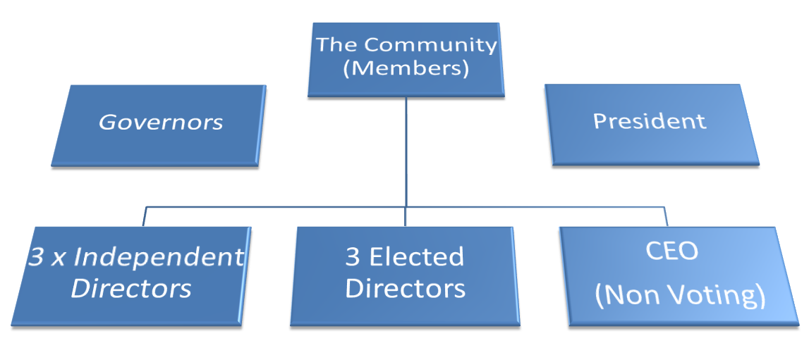

Alongside the current composition, we also have:
- A co-opted Independent Advisor (Non-Voting) - Richard Barker
- Home Country Representatives
  - England - Chris Keighley, Parkour Generations
  - Wales - Craig Robinson, Fluidity Freerun
  - Scotland - Chris Grant, Glasgow Parkour
  - Northern Ireland - Colin DeVenny, Belfast Parkour

The current representation of Parkour UK is 12 - which is made up of 3 Independent Directors, 3 Elected Directors (These are the voting and registered directors of the company) CEO, Independent Advisor & 4 Home Country Representatives (all non-voting & not registered as directors of the company).

This representation model has been heavily highlighted to the UK Sports Council in the recognition process thus far, but they have indicated they would like more formal inclusion of these (the current non-voting & not register as directors of the company) within the Mem & Arts and on the board (as detailed at the 2014 AGM). This desire is also echoed by our members.

Proposed Composition:

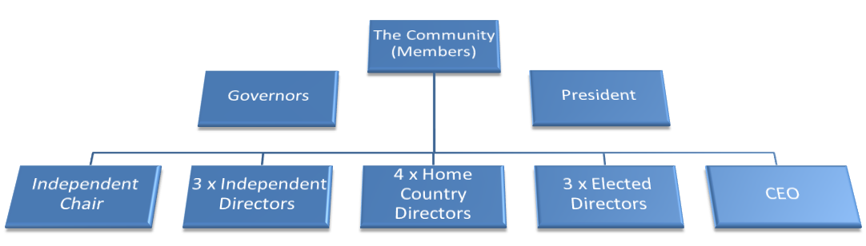

The proposed board composition is a formalisation of our existing composition. The UK Recognition Panel & UK Sports Councils have indicated that this needs formalising both in the Memorandum & Articles of Association as well as in practice.
      - The Chief Executive outlined current best practice with other NGB’s and explained that standard now being expected by the UK Sports Councils is a board of twelve.
      - The Chief Executive outlined that the vote on the proposed Memorandum & Articles of Association has been fully devolved from only the current voting members (under the current Articles) to ALL members, as it was important that this change is a decision ALL members must decide upon, in addition it was in the ‘spirit’ of the changes the NGB wishes to implement moving forwards.

The Chief Executive went through the proposed Memorandum & Articles of Association line by line addressing any queries to the changes advised (as above) and to provide any clarification on existing clauses.

SPECIAL RESOLUTION

The chair outlined the proposal for the adoption of the special resolution. A vote by all members was undertaken and the proposal was carried with 10 for, 0 abstain 0 against.

The chair confirmed that the proposed special resolution was carried and that new Memorandum & Articles of Association would now be adopted.

The chair wished to thank Lucy Katan from the Sport + Recreation Alliance for independent invigilating the meeting & independent counting / invigilating the voting papers

Please see the attached letter from the Sport + Recreation Alliance confirming independent invigilation of the meeting & vote counting (appendix two)

ANY OTHER BUSINESS

The Chief Executive outlined the continued encroachment beyond proper limits by British Gymnastics via FreeG / Freestyle Gymnastics into Parkour/Freerunning, a separate sport / activity.

The Chief Executive outlined that on-going all recent & previous dialogue is taking place with both Sport England & British Gymnastics detailing our current concerns / issues that this encroachment is having on Parkour/Freerunning.

The Chief Executive outlined the that a meeting facilitated by Sport England with British Gymnastics took place in October 2013, to air our issues & concerns relating to the encroachment in our sport and to begin looking at all options for an appropriate resolution. Parkour UK did request that an independent observer be present at the meeting. Sallie Barker from the Sport & Recreation Alliance agreed to attend as an independent observer. Unfortunately our request was not facilitated.

The Chief Executive outlined that since the meeting taking place with on-going dialogue has taken place with both Sport England & British Gymnastics in relation to some of the issues & concerns we raised at that meeting.

The Chief Executive outlined that in June 2014 he wrote to British Gymnastics, following up on the meeting from October 2013 and the subsequent dialogue relating to our issues/concerns. This correspondence was to highlight the significant changes Parkour UK had made in terms of recognition, as well other updates. Additionally to pick up on the increased encroachment and the subsequent confusion caused by FreeG/Freestyle Gymnastics from both British Gymnastics & their members. Therefore requesting a meeting with Sport England & British Gymnastics to discuss and appropriate address.

Unfortunately this request was not accepted by Sport England. The CEO did write back requesting that our fair and reasonable request for a meeting with Sport England (not with British Gymnastics) be re-considered so that we can appropriately and amicably address our legitimate and significant concerns. Alternatively, we would request mediation and/or arbitration with both British Gymnastics & Sport England via Sport Resolutions dispute resolution service to amicably reach a mutually agreed settlement.

To date there has been no response from Sport England or British Gymnastics about meeting. Therefore it’s likely that we will request mediation and/or arbitration with both British Gymnastics & Sport England via Sport Resolutions dispute resolution service to amicably reach a mutually agreed settlement.

The Chief Executive detailed that both Sport England & British Gymnastics were formally invited to resolve the dispute via mediation and/or arbitration with Sport Resolution. The formal invitation was sent on the 16th September asking for a formal response within 14 days. Both parties responded on the same day, the 30th September 2014. Both parties had refused to engage with mediation and/or arbitration. The Chief Executive read out both formal responses.

The Chief Executive outlined that the board had agreed that we would continue to challenge the encroachment via mediation and/or arbitration with Sport Resolutions.

The Chief Executive outlined that the board had agreed that we would meet with Ed Proctor, Executive Director at Sport Resolutions & also Sallie Barker of the Sport & Recreation Alliance to discuss next steps.

The Chief Executive outlined that the board had agreed that we would formally respond to both Sport England & British Gymnastics, outlining our dispute in further detail. This response would be sent following the meetings with Ed Proctor & Sallie Barker.

The Chief Executive outlined that the board had agreed that we would keep Baroness Tanni Grey-Thompson & Karen Buck MP, updated on the progress to date. Both are highly supportive of our stance in regards to the encroachment by British Gymnastics.

The Chief Executive outlined that the board had agreed that the encroachment remains and issue and that Parkour UK should be proactive in addressing it, however that our main priority at this time is achieving recognition.

Several members re-affirmed their issues / concerns surrounding the introduction of FreeG / Freestyle Gymnastics which echoed Parkour UK’s concerns.

Several members expressed concerns relating to impact on their livelihoods by the impact of FreeG as there is considerable confusion relating to who is appropriately qualified to deliver what sport/activities. Additionally around potential reputational damage, particularly in relation to accidents/insurance claims relating to FreeG, as this is often perceived as or confused with Parkour/Freerunning.

The Chief Executive noted the member’s issues / concerns and asked for members to highlight any additional concerns or information relating to FreeG directly to him. The Chief Executive detailed that he would collate members concerns and highlight these with Sport England & British Gymnastics and/or via the proposed dispute resolution, facilitated by Sport Resolutions.

The Chief Executive re-affirmed Parkour UK’s position on the encroachment by British Gymnastics into our sport and Parkour UK will be proactive in highlighting the issues /concerns with relevant parties. The Chief Executive asked members to refrain from publicly airing concerns / issues via social media, public meetings etc, but in the short and medium term to refer these to Parkour UK to take up directly with British Gymnastics & Sport England and/or via the proposed dispute resolution, facilitated by Sport Resolutions.

The Chief Executive re-affirmed Parkour UK’s commitment to seek and amicable resolution to the encroachment. The Chief Executive also highlighted that there are mutually beneficial opportunities available to both Parkour UK & British Gymnastics, if a resolution can be reached and that FreeG is more appropriately/correctly positioned. Additionally there are additional benefits for consumers/participants and Sport England (as well as the other UK Sports Councils) on increasing participation through exploring these mutually beneficial opportunities.

The Chief Executive re-affirmed Parkour UK’s commitment to look at different, innovative ways of working with partners, others NGB’s and the sports councils both to the benefit of Parkour/Freerunning & consumers/participants.

There being no further business, the meeting closed.

The Chair thanked all attendees for attending the Special Congress and outlined that the future for Parkour/Freerunning is looking very positive now and post-recognition, however there is still a significant amount of work to do. The Chair encouraged members to continue the positive work they are doing and that Parkour UK will support them as best they can with the resources available to us.

SIGNED by STEPHEN MICTHELL ) ……………………………………………… Independent Chair
SIGNED by DAN EDWARDES ) ……………………………………………… Elected Director
SIGNED by EUGENE MINOGUE ) ……………………………………………… Chief Executive
5th November 2014

